Profile

1. Name : **J. MURALI KRISHNA**

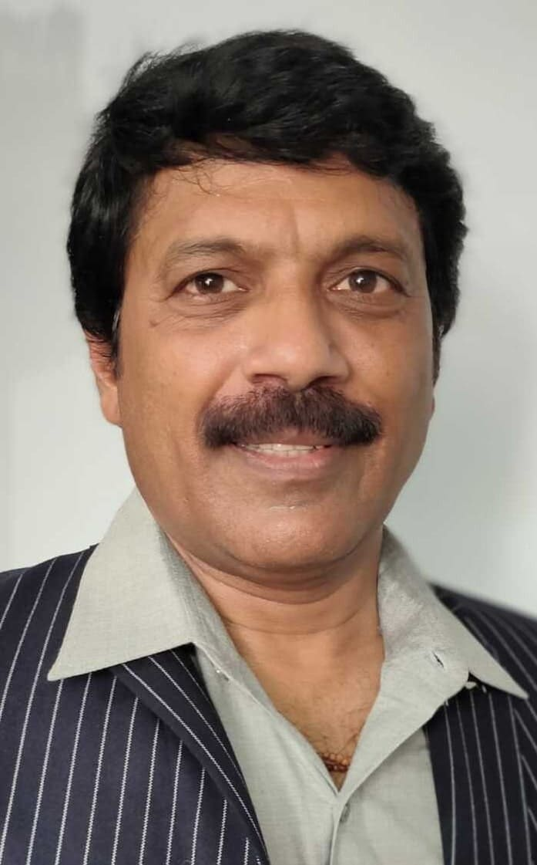

1. Designation : Lecturer in Commerce
2. Date of Birth : 15.05.1966
3. Educational Qualifications : M.Com
4. Teaching experience : 32 Years
5. Research Experience : NIL
6. Dissertation/Thesis Title : NIL
7. No. of Research publications : NIL
8. No. of Books Published : NIL
9. No. of Major/Minor Research Projects: NIL
10. Title of Minor Research Project : NIL
11. No .of International Conferences Attended : NIL
12. No. of National Conferences Attended : NIL
13. No. of Papers Presented at the Seminars/Conferences: NIL
14. Refresher Courses/Orientation Programs/Training Programs Attended: 01
15. Vidwaan Score :
16. Address : 19-9, Flat No. 2/6, Sri Sairaj Residency,

Chetlapalli vari Street,

PENUGONDA-534 320; W.G.Dt.

1. E-mail Id : j.muralikrishna@yahoo.co.in
2. Contact no : 80746 38034